**Lab 4**

Georeferencing and Editing in ArcGIS Pro

# **Learning Objective:** This exercise will introduce you to georeferencing an aerial photo with no location information in the metadata and editing by adding new points, lines, and polygons.

**QUESTION 1: What coordinates have your image been placed at (hint: the coordinates are shown at the bottom of your ArcPro page)? Why might this be the case?**

The images were placed at 0° x 0°. The images have no coordinate info, so they go to the default coordinates.

**QUESTION 2: What is different between the photo you georeferenced and the one you haven’t georeferenced yet? (What did the georeferencing tool do to the photo?)**

The first photo is overlayed over the current location. The control points mapped buildings and landmarks to actual coordinates in order to correct the image and distort it to line up accurately with the real world. The second photo does not fit accurately over the real world yet, since its landmarks have not been mapped to accurate coordinates.

**QUESTION 3: Now that both of your images are in the “right” place, what are some differences that you notice between the two years (use other maps if you need help with names of buildings or other locations)? You must name at least three differences and correctly reference which years something appeared in the image and while year it did not (or vice versa).**

* The Bean residence halls were built between 1960 and 1968
* There is a large ‘X’ present on Hayward Field in 1968, but not 1960
* The 1968 map covers significantly more area. This could be because the campus expanded, or because the later image was simply of a larger area

**QUESTION 4: What do you see in the attribute tables? (Is there any data?)**

The attributes tables are empty, and there is no data. This will remain empty until we add in points, lines, or polygons.

**QUESTION 5: Write a short paragraph where you envision a map which has buildings digitized at each of the years of the photos available on the Library website (not just the two years you picked).**

1. **How do you imagine this map would function?**
2. **Would you make separate layers for each year’s additions/subtractions? Would you just make those differences clear in the attribute table? There isn’t a wrong answer from these options, just make sure to defend your answer.**
3. **What could you do with that map when it is done?**
4. **Who might use this map?**
5. **What patterns might you see? Hint: You may have to look at the images from other years than the years you georeferenced, no need to georeference them, just have look in your web browser.**

I imagine a digital map with a slider that control which year’s data are shown. For example, if the slider is all the way to the left, only the layers of data from the 40’s and before would be shown. If the slider is at the right, then more recent data would be shown. To enable this, each year’s data would be kept in a separate layer that could be toggled on or off. This would allow the user to scroll through the changes that took place on campus of the years by simply clicking and dragging their mouse. This could be useful to construction planners, giving them the ability to inform their decisions based on how the campus has historically grown and developed. It might show patterns such as when the campus went through periods of rapid expansion, reconstruction, tree and garden planting, etc. vs. periods of relative stagnation.

**GRAPHIC 1: Take a screenshot of the two files in Windows Explorer.**

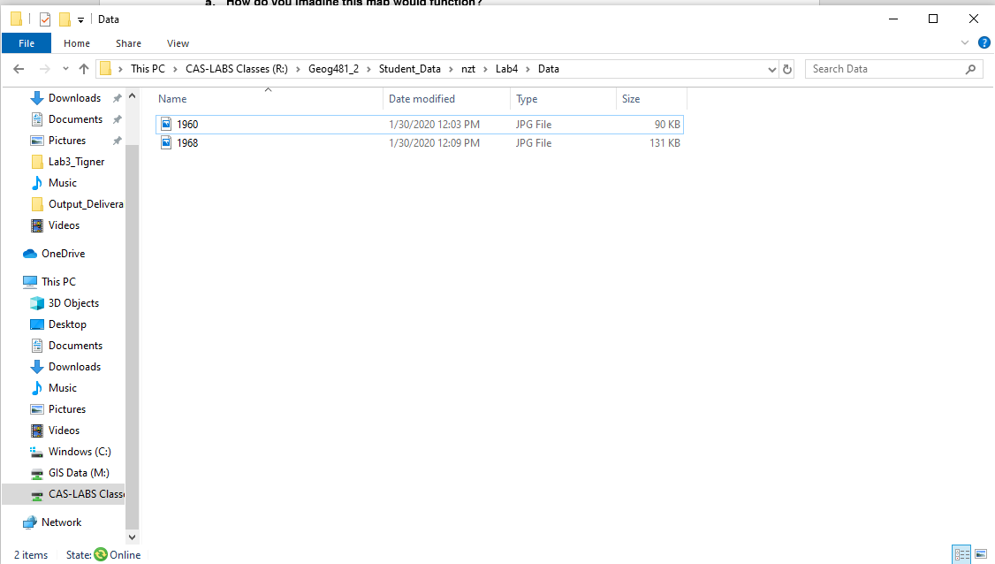

**GRAPHIC 2: Take a screenshot of your Control Point Table**

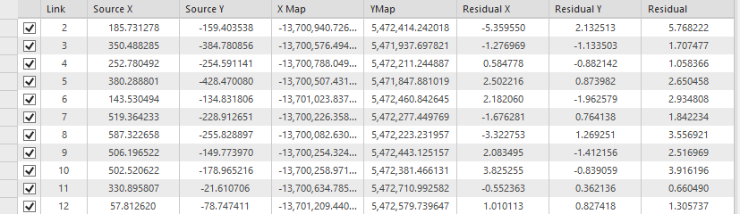

**GRAPHIC 3: Take a screenshot of your image with the control points.**

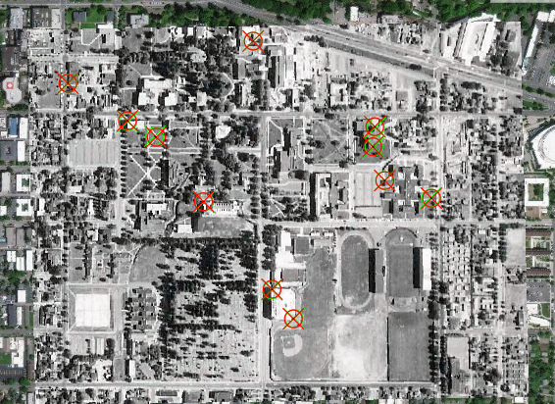

**GRAPHIC 4: Take a screenshot of your updated Attribute table.**

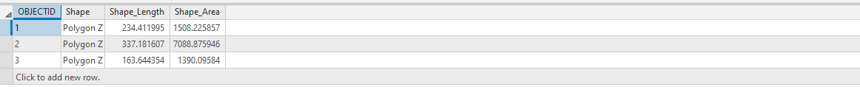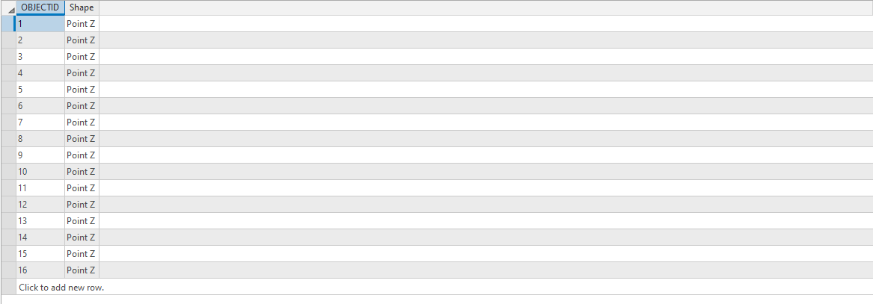

**GRAPHIC 5: Take a final screenshot of the whole UO campus with your points, lines, and polygons.**

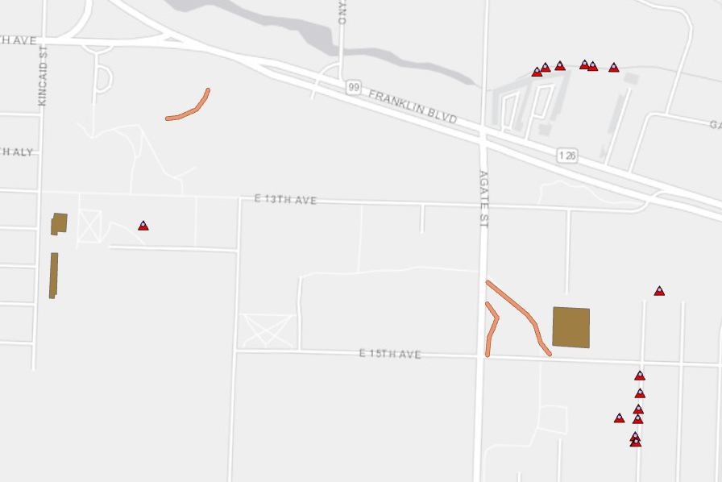

# **Deliverables:**

1. Questions 1-6
2. Graphic 1 - 2